Instructions for Smaller Dog and Cat Beds

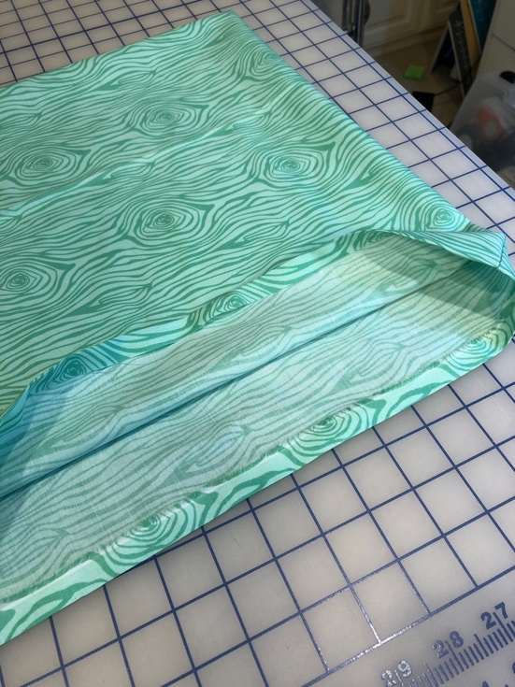
Cut 2 pieces of fabric approximately 16x16 inches. Put right sides together and sew along 3 sides. Turn right side out and iron a ½ inch seam allowance along the 4th side.

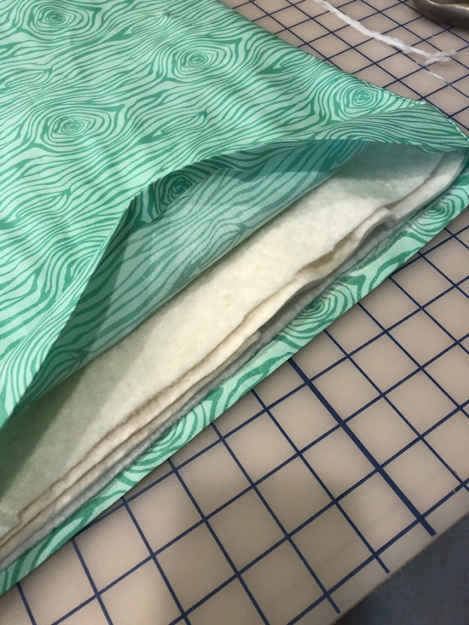
Cut 3 layers of batting about ½ inch smaller than the finished size of crate pad and insert in case.

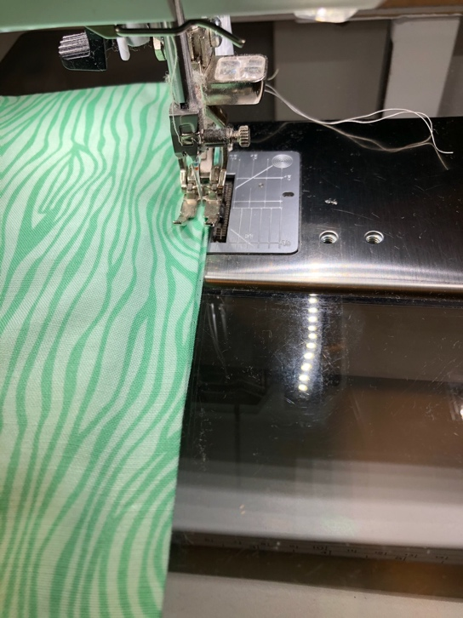
Sew crate pad shut with a narrow seam.

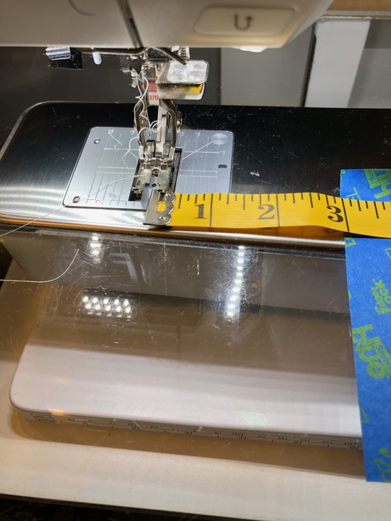
Measure 3 inches from your needle and place a piece of blue tape.
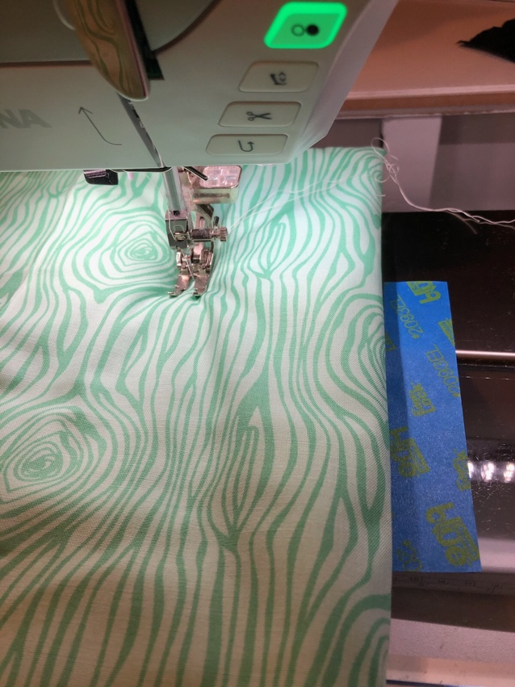
Quilt 3 inches in from outer edge on all 4 sides of crate pad.

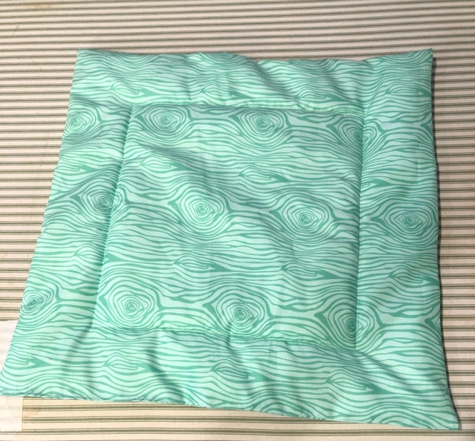
Finished Project! The pad can be square or rectangle – depending on your scraps. Any size is OK. I generally make them 15 – 20 inches wide and long.

